**Learning Aim A: Understand the principles of website development**

**Purpose Of Websites in General**

The purpose of a website is to inform consumers about goods or services. They also present and share information to increase the publics knowledge and make them more aware of certain matters. An e-commerce website would have a purpose to try to sell their goods to consumers whereas the purpose of a non-profit website would be to inform people.

**Two Websites**

The two websites I have chosen to compare are <https://www.prettylittlething.com/> and <https://www.boohoo.com/>. These are two fast fashion clothing brands.

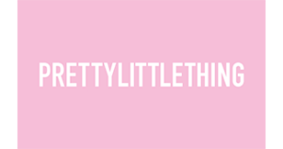

**Target Audience**

Pretty Little Thing: The target audience for Pretty Little thing is women. Pretty Little thing would also appeal to teenage girls. They have targeted ranges for all different types of people in the target audience, for example plus size and petite. This is an e-commerce website, so their target audience is consumers, and they are trying to sell their products to them.

Boohoo: The target audience for Boohoo is men and women. They also appeal to teenage boys and girls. They have two sections of the website, one being ‘Boohoo Men’ and one ‘Boohoo Women’. Boohoo also has a shop by figure option, where they have specific ranges for different members of the target audience. Boohoo is an e-commerce website as well and they will be promoting their products and their target audience is their consumers.

**Type Of Website**

Both websites are e-commerce websites, so they are trying to sell their products to consumers. Boohoo and Pretty Little Things websites need to be influential and try to persuade their consumers to buy the product perhaps by advertising deals and discounts.

**Purpose Of Pretty Little Thing and Boohoo’s Website**

Both websites have a purpose of informing their customers about the products they are trying to sell. They use e-commerce as the way they sell their products as neither of these brands have the option for customers to shop in store. They try to sell their products by displaying discounts and their deals to persuade customers to buy their products.

**Website Layout**

The opening page of the boohoo website is a tabular format. There is a banner at the top and multiple rows with one column. There is also a footer at the bottom of the first page.

Pretty Little Thing’s website opens to a page with a tabular format. It has a banner at the top of the page. The page has rows and one column. There is also a footer at the bottom of the page.

**User Friendly**

Boohoo’s website is very user friendly and easy to get around. All its pictures are links to different pages so users can easily see what the are clicking on to. The website is accessible for those with visibility issues with the most important text being enlarged. It has drop down menus so users can move from page to page easily.

Pretty Little Thing’s website is also user friendly and easy to navigate. It has images which are easy to understand if you have literacy problems. There is white space, so the user has a place to rest the eye. The website also has large text; therefore, it is easy to read for visually impaired users. Pretty Little Thing’s website also has drop down menus for easy navigation.

**Consistency**

Boohoo’s website is consistent with each page having a row with text about the page and what category of clothes you can find on the page. Each page has the same banner at the top, so this maintains consistency on each page. Each page has five columns displaying the clothes.

Pretty Little Thing’s website is consistent with the same banner at the top of each page. Each page has four columns displaying the clothes and a menu at the side to sort the products to what the user wants to see. At the top of each page there is a row with text about the products on the page to inform the user.

**Navigation**

Boohoo’s website is easy to navigate with images that are hyperlinks. There is drop down menus to easily move from page to page. The banner is good for navigation as each word take the user to a different page when it is clicked.

Pretty Little Thing’s website is also easy to navigate with pictures that are hyperlinks. The banner has drop down menu from each word. The sidebar has a menu to easily sort the products so the user can find exactly what they need.

Search Bar

**The Purpose of Content Based Websites**

Log Into Account

Colour

Images

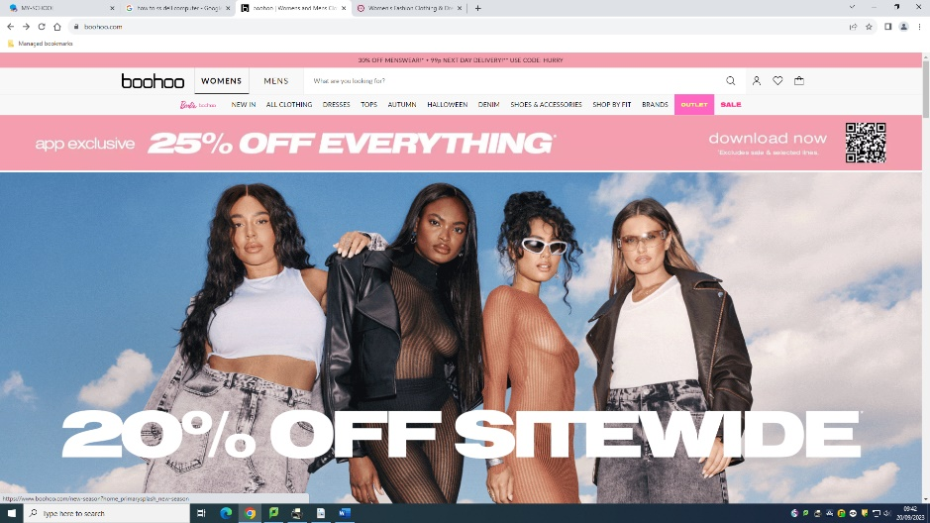

Buttons to interact with

Minimal Text

Boohoo is Web 2.0 as it has a search facility for users to find specific items using key words. Users can log into their account and here, they can track and view their orders. Boohoo also has images and buttons that can be interacted with to increase interactivity for the users.

Log Into Account

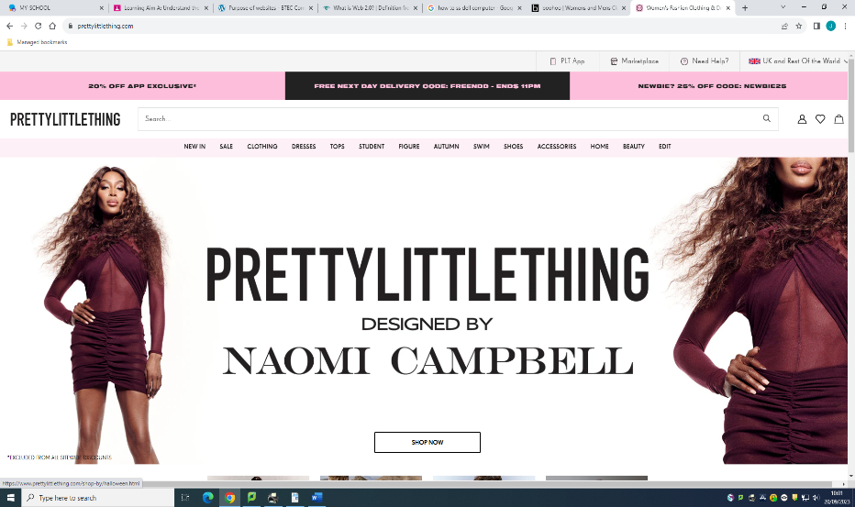

Search

Colour

Buttons to move to different pages

Slideshow

Minimal Text

Pretty Little Thing is Web 2.0 as it has a search bar for users to look up specific things they want, it also has the option for users to log into their account where here they can track their order. The website has a slideshow and navigation buttons which makes it more interactive for the user.

These websites are Web 2.0 as they are dynamic web pages and can be interacted with by the user. Web 2.0 pages supports user generated content and social networking. Web 1.0 has the purpose of content browsing and finding information. Web 1.0 contains mainly text rather than many images, movies or interactive buttons. Information on Web 1.0 is provided in a linear format with lists and pages whereas Web 2.0 is in a non-linear format. An example of web 2.0 is social media apps like Facebook or Instagram.

**Customisable**

Pretty Little Thing’s website can be customised by the user to display a different version to suit a country. This changes currency and language.

Boohoo’s website also has the option to change the site to a version of a different country. This then puts the website in a different language and currency.

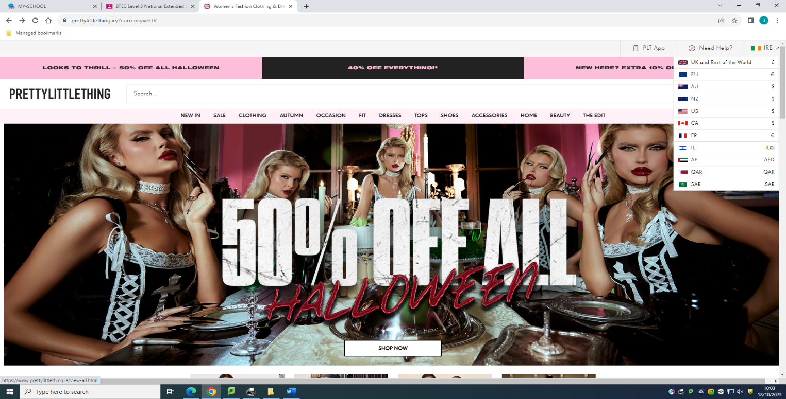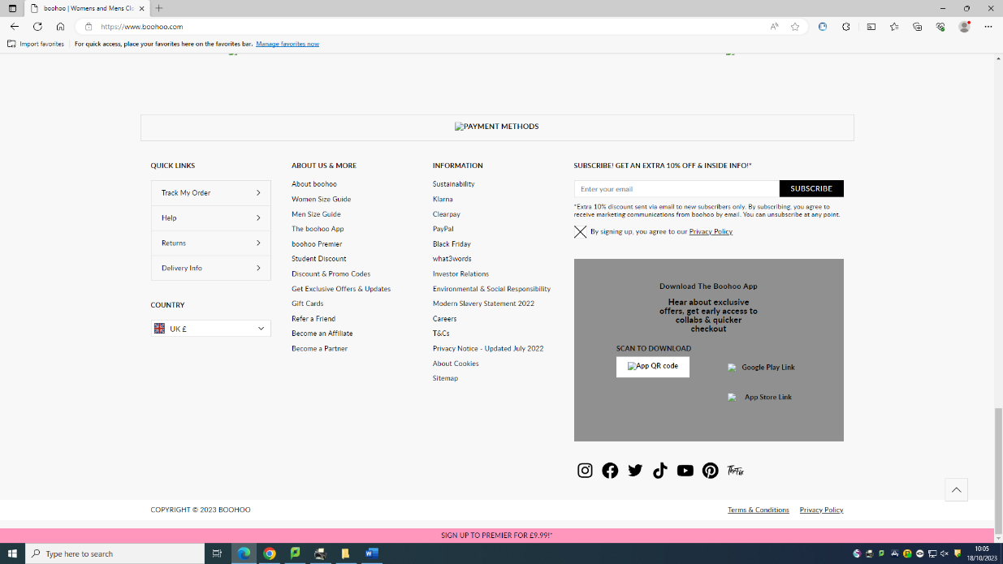

**Responsive**

Both websites are responsive to different devices and the layouts of the pages adapt to different screen widths etc.

**Purpose of Website design**

Usability

Boohoos website is easy to use with navigation buttons to aid the user in moving around the website.

Pretty Little Thing’s website is also easy to use with the navigation bar in the banner and pictures can be clicked on to move to other pages.

White Space

Boohoos website does not have much space with coloured images stretching across the width of the website. There is not much space to rest the eye.

Pretty Little Thing’s website has a fair amount of white space, enough for the user to rest their eye but there is also coloured images to make the website appealing and entertaining for the user.

Site Layout

Boohoos website is laid out in a tabular format with columns and rows meaning it is well organised for the user to use.

Pretty Little Thing’s website is also laid out in a tabular format with columns and rows. It appears organised.

Accessibility

Boohoos website is not that accessible. However, it does have the feature to zoom up on products but not text. The text on the home page is large however on other pages it gets quite small.

Pretty Little Thing’s website is not very accessible, but it also has the feature to zoom up on clothing. The text on the website is also quite small and may be difficult to read for the visually impaired.

Spacing

Boohoo has not used spacing very well. Their home page consists of pictures continuously after each other with only a small line of white. There is also not much space between the header and the body. There is very little space between each product when they are displayed in tabular format.

Pretty Little Thing’s spacing is better as they have more white space and more gaps between each picture on the home page. The spacing between each product is even and is not too small.

Navigation

Boohoo’s website has good navigation with pictures that are hyperlinks to other pages as well as a navigation bar below the banner. You stay in the same tab when opening a new page, so it is easier to go back.

Pretty Little Thing’s website is easy to navigate with a navigation bar and a sort/filter bar. You also stay in the same tab when opening new pages.

Typography

Boohoo’s website is consistent with their fonts, they have sans serif font for their black text. Any larger text across images etc. is consistent.

Pretty Little Thing’s website is also consistent with their fonts using sans serif font for black text. They have consistency between certain fonts for different sizes of text.

Alignment

Boohoo’s alignment is centred but there is minimal white space, each page’s content fills the width of the screen.

Pretty Little Thing’s websites alignment is centred with white space at each side. However, when looking at the products it appears as right aligned as the sort/filter bar does not stretch down the entire page and there is white space to the left of the products.

Clarity

Boohoo’s website is slightly too busy and there is too much going on with too many flashing texts and images.

Pretty Little Thing’s website is clearer with more white space and text is on a clear coloured background instead of over images every time.

Consistency/Intuitiveness

Boohoos website is consistent with the same banner and footer on each page as well as the same navigation bar. It also has an intuitive design using pictures and coloured icons to show colours of items, users will know exactly what to click and it is not confusing.

Pretty Little Thing’s website is consistent with the same banner and footer on each page and the navigation bar is consistent. It is also intuitive with icons and pictures for the user to click, it is easy to understand.

Accuracy

Boohoos website is very accurate, it has no spelling mistakes. The website is up to date with any sale updates posted. Tracking of orders is updated in real time.

Pretty Little Thing’s website is also accurate with no spelling mistakes, and everything is up to date. Order tracking is in real time.

Content

The content on boohoos website is advertising products, this is done in an appropriate way and customers can clearly see the item, price and size etc.

Pretty Little Thing’s content is also selling products, the content is displayed clearly with customers feeling no confusion.

Media

Boohoo has lots of media with the home page full of images at 100% width of the website. The media is colourful however I think that there may be slightly too many images and too much colour.

Pretty Little Thing’s website has lots of media and images. However, there is white space to contrast the colour which makes it easier on the user’s eye.

Simplicity

Boohoo’s website is not simple. It is too busy with too much colour. It may be hard for the user to focus, and they do not have anywhere to rest their eye.

Pretty Little Thing’s website has a balance between colour and white space. There is enough colour to make the website appealing to the user but white space for the user to rest their eye.

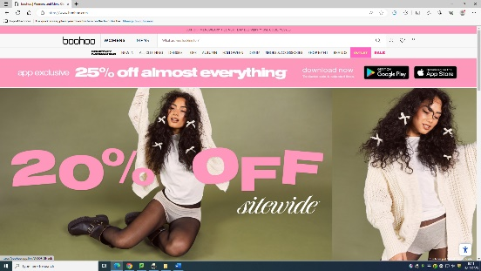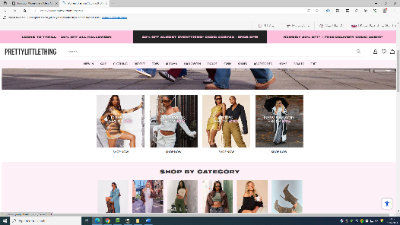

**Media and Objects**

Position

Pretty Little Thing has positioned many of their media and objects on their home page with having logos in the footer and many hyperlinked images. They also have them placed sporadically throughout the website.

Boohoo has also positioned many of their media and objects on the front page with logos in the footer and hyperlinked images on the homepage however they also have them throughout the website.

Colour

Pretty Little Things website has a colour scheme of pink and white. These colours go well together and will most likely not overstimulate the user. However, there is certain places on the website that there is too much colour which could be an issue for those with photosensitivity.

Boohoo’s website also has the theme of pink and white but in my opinion Boohoo’s website is too busy with too many colours especially on the home page of the website as the images are the width of the screen.

Contrast

Pretty Little Thing’s website contrasts colour by either having a white background which makes the coloured images of products stand out more to the user.

Boohoo’s website also contrasts colour by having a white background to make the images of product stand out to the user’s eye.

Size

The images on Pretty Little Thing’s website are adjustable and shrink to fit onto a mobile phone screen so the user does not have to continue scrolling to see content.

Boohoo’s images also shrink to fit on a mobile phone screen so that users can see all content without scrolling large amounts.

Appropriateness

Pretty Little Thing makes effective use of media and objects and all of them are relevant for example links to their social media pages or icons to show what payment methods are accepted. These things are useful to the user and are appropriate for the type of webpage.

Boohoo also makes appropriate use of media and objects and uses them for relevant matters. For example, icons to sign in and to access the basket and the links to social media pages. The user uses these frequently, so they are appropriate for the type of webpage.

**Creativity and Innovation**

Pretty Little things website does not have an unconventional layout and is quite basic. The layout is basic. The images do scroll to the left on certain rows which therefore does give the website some originality. The website has a balanced amount of white space and colour, so the website is still engaging for the user but also gives the user a place to rest their eye. The website is very basic and does not have any outside the box thinking but it is simple for the user to see the products they need. The website is not overly aesthetically pleasing but the colours of pink and white may be seen as ‘pretty’ by girls making them want to shop on the site.

Boohoo’s website is also very basic with a conventional layout. The images are static which little creativity however the images being 100% width of the screen may be seen as creative by the user. The website has little amounts of white space and may be seen as too ‘busy’ by the user as they have no place to rest their eye. The website follows a simple basic layout and does not have very much originality or outside the box thinking. The website is also not overly aesthetically pleasing but it also has the pink and white colour scheme which may make girls want to purchase from them.

**Search Engine Optimisation**

When searching ‘women’s party clothes’ Pretty Little Thing comes up 6th in the list for suggested websites meaning their meta tags/web page headings are used for keywords. These meta tags are useful to the user as it shows them exactly what is on the page and means they will find the website using these as key words. PLT also comes up 6th on the list when women’s clothes are searched on google meaning it is a popular brand and people often choose their website after searching women’s clothes. Pretty Little Thing may need to update their website, so they appear higher up in search results.

Boohoo’s website comes up second when ‘women’s party clothes’ is searched which shows that the business’ website has been recently updated causing them to be higher in search results. The meta tags must be relevant to what is on the pages and the headings of the pages must be relevant to cause their website to come up so high in results. This high result shows that the business is frequently clicked on by users after searching up women’s party clothes as keywords. However, Boohoo does not come up on the first page of search results after ‘women’s clothes’ is searched up meaning other websites are more popular for these key words.

**Learning Aim B: Design A Website to Meet Client Requirements**

**Problem Definition**

I had a brief conversation with the client to discuss the requirements for the website and to outline what is expected from the website. The client outlined that they wanted, “Five pages including a Home, Our Staff, Job Requirements, Application Form, and Web Courses page, a banner, a red colour scheme, a footer with company details and a movie on one of the pages.”

**Intended Audience**

One of the intended users of the website is Hot Beans Web as a business who are paying for the service, but also for the visitors to the website who are interested in Hot Beans Web as a business. These people need to be attracted to the website and they need to be encouraged to revisit or even bookmark the website.

**Problem To Be Solved**

A questionnaire and an interview took place so that I could find out fully what problem the website was created to solve. The website is being made to solve the problem of recruitment. It is a place for applicants to see requirements clearly and to find out lots of information about the business before applying reducing the time wasted by Hot Beans Web when people did not meet the requirements of the job.

**Constraints**

One constraint that may be experienced is a limitation with time. The client wants the website completed within 3 weeks however, it could be perfected to a higher level with more time available. Another constraint that may be experienced is a limitation with budget. The client only wants to spend a certain amount on the service but with more time and money, I could make a better version of the website. Another constrain that may be experienced is a lack of staff training, if I am unable to fulfil one of the client’s requirements due to a lack of experience or training, they may be unsatisfied with their website.

**Benefits**

There are many benefits the business will get from this website being developed. Some include the business is accessible 24/7 and they will not be limited to their store opening hours reducing levels of potential customers. Another benefit is that the business is accessible worldwide and is not limited to one certain geographical area again boosting the number of customers. The website will also be cheaper in the long run rather than paying for advertising in the newspaper and on the radio which can be relatively expensive. Forming a website also gives you the opportunity to gain long term clients which will help the business to grow and expand.

**Nature of Interactivity**

The client and I discussed the level of interactivity that was wanted in the business’ website. We agreed that a movie would be added and a scrolling marquee as well as a map being embedded. The user did not want too much interactivity that the user is overwhelmed. We want to get the balance right between static and dynamic. If the website was an ecommerce website for Hot Beans Web, we could add a filter bar so that customers could set their preferences and add a Transported Layer of Security for the customer to make purchases.

**Complexity Of the Website**

Our intention is not to make the website too complex that it will overwhelm the user but to ensure that there is enough colour and interactive elements to keep the user engaged and to ensure they return but also to provide them with white space to rest their eye. We want to keep the website simple as simplistic websites are usually more often visited and we want to ensure that the message is easy to get across with a clear and simple easy to use design so that users are able to get what they need from the website without fuss.